

A
MINI PROJECT
Real Estates

Under the Guidance of
Mr. Anurag Sir

Submitted by

Name Registration no. Section
Karan Panchal  Harsh  Ashif Ahamad | 12217078  12217109  12217380 | KOC29  KOC29  KOC29

TECHNOLOGIES USED

1. HTML
HTML stands for Hypertext Markup Language. It is a standard markup language for web page creation. It allows the creation and structure of sections, paragraphs, and links using HTML elements (the building blocks of a web page) such as tags and attributes.
2. CSS
Cascading Style Sheets, fondly referred to as CSS, is a simple design language intended to simplify the process of making web pages presentable.CSS handles the look and feel part of a web page. Using CSS, you can control the color of the text, the style of fonts, the spacing between paragraphs, how columns are sized and laid out, what background images or colors are used, layout designs,variations in display for different devices and screen sizes as well as a variety of other effects.

ABOUT THE REAL ESTATE

PROPERTY WEBSITE :
The project is a basically a property website created to sell or buy the properties very easily.

OBJECTIVE :
In the dealing of any type of property , one have to do a lot of paper work formalities which takes a lot of time and running to the government offices so many times. So, we have created a website to resolve this problem of many clients. The main objective of our project is to provide ease to the clients on selling or buying their properties online then there will be no need to run around the offices . Clients can access all the information online just they need to have a good internet connection and the desires for the property .

DISCRIPTION :

There is a simple interface of the website which is distributed into some important sections such as :
- Sign up
- Post Property
- Sell
- Buy
- Rent
- Contact us

First the client has to do sign up in the website to access all the relevant data .
There is a section to find the house in the particular location , they can select the property type that they want to buy like bungalow , flats , etc… they can also select for renting the property . If the client want to contact us then there is an option for contacting us from the website itself .

SOME CODE SNIPPETS:

DIV TAG :

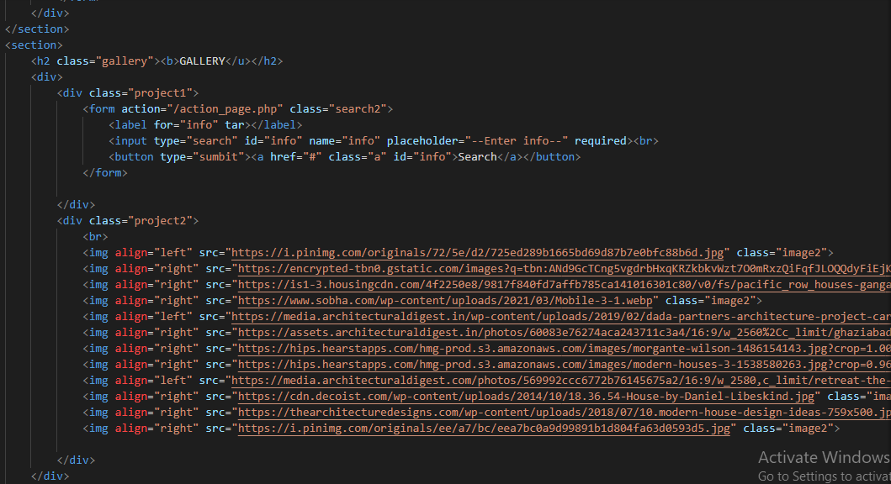

NAVIGATION BAR :

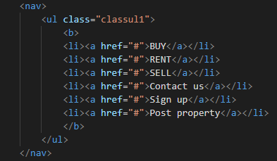

HEAD:

